Configuring GIT on LINUX machine

Create an Instance and download required package:

* yum update -y
* yum install git -y

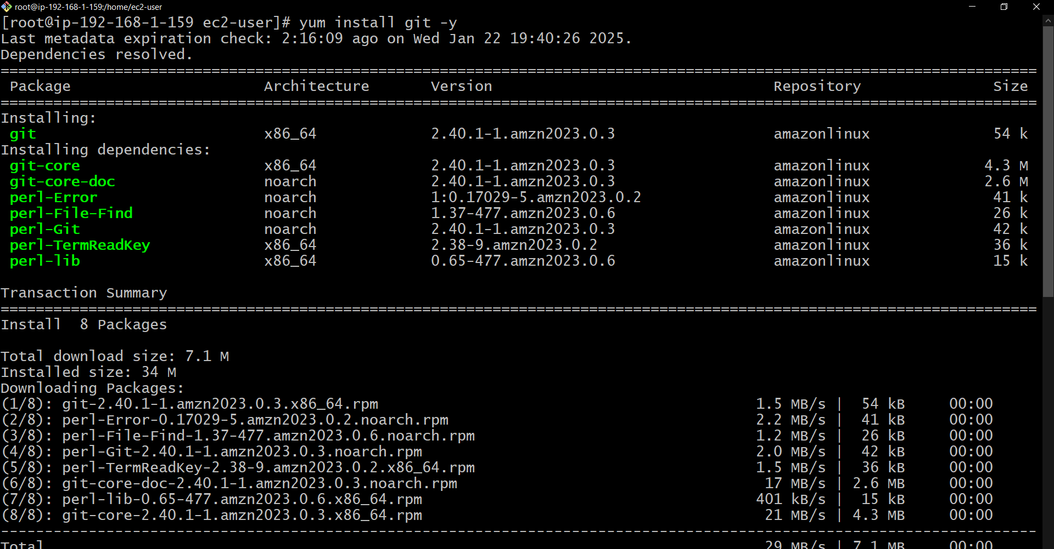

Add the github account confg to linux:

1. git config –global user.name <username of github>
2. git config –global user.mail <mail address of github>

Create a private and public key by ssh and copy the public key to GITHUB:

1. ssh-keygen -t rsa -b 4096 -C “comment”
2. define the path

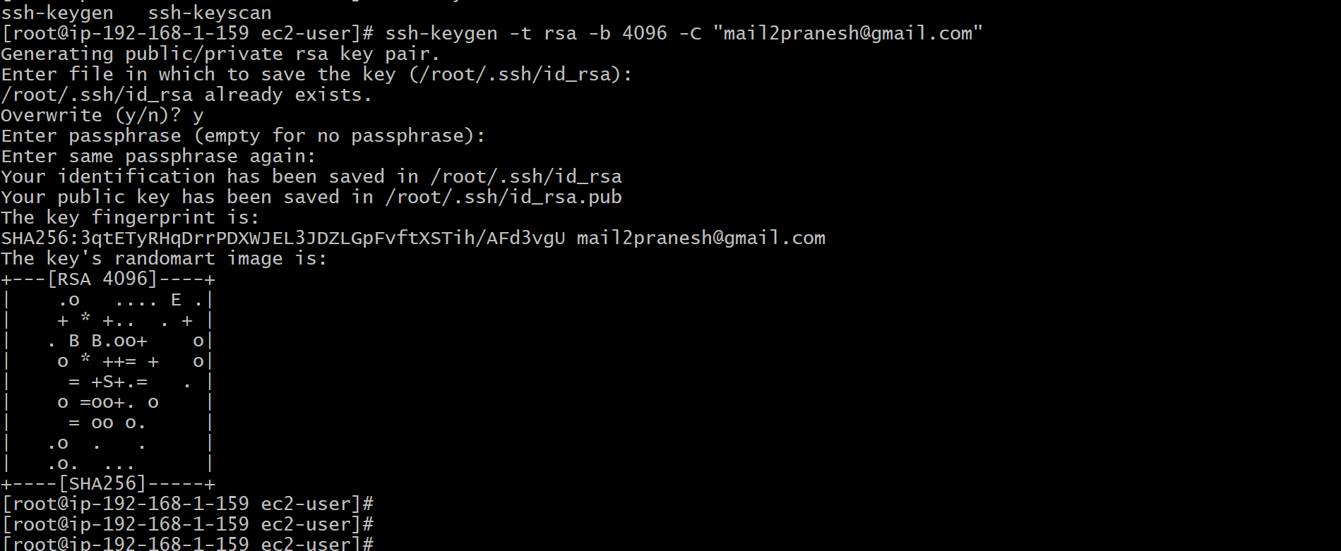

1. Now add ssh agent to the key so that it wont ask auth for every git command
2. eval “$(ssh-agent -s)”
3. ssh-add /root/.ssh/<priv-keyfilename>

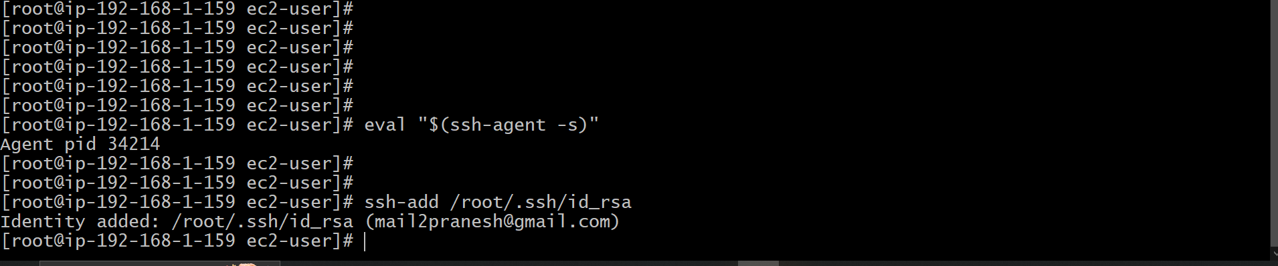

Now cp the public key from /root/.ssh/id_rsa.pub

And paste it to github account in Setting-SSH and GPG key – new ssh key paste it here.

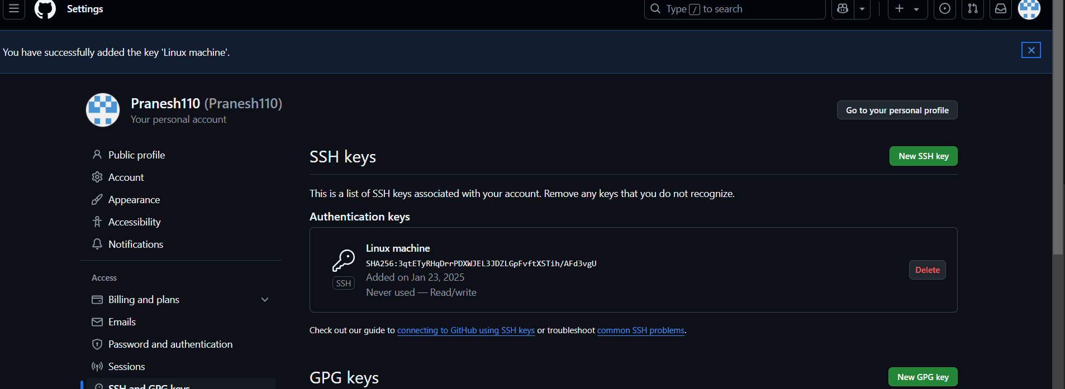

Clone the github repo to our local machine:

1. git clone <ssh url of the repo>

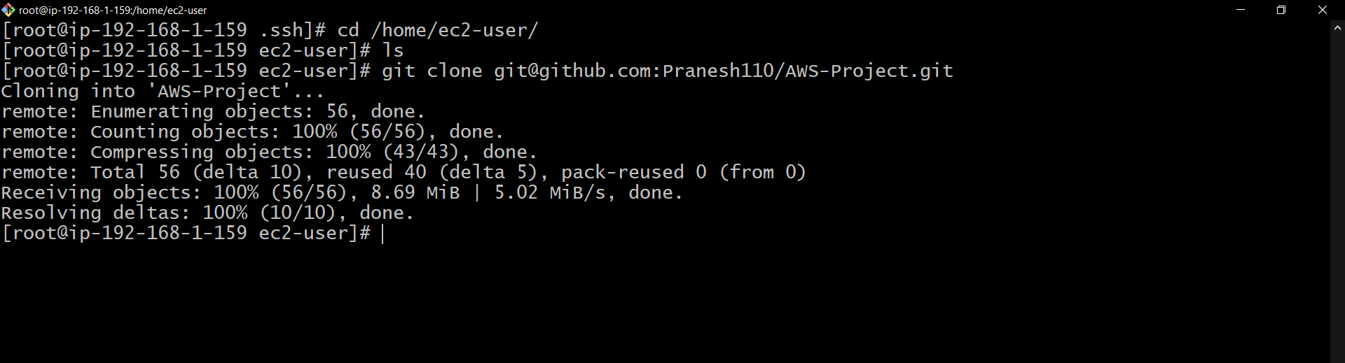

To push and pull for any change made:

Consider any files or added or removed or edited.

1. git add . – for staging the action made
2. git commit -m “comment” – to commit the action made

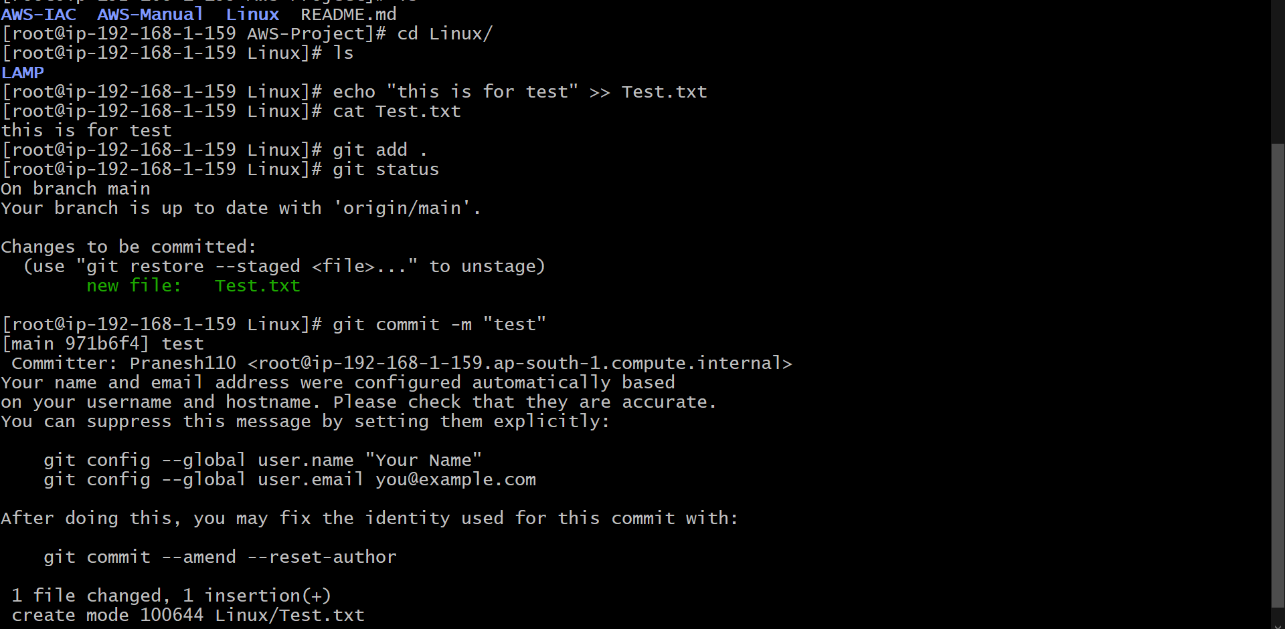

1. git push origin “brance_name” – to push the changes made in local to git hub

Now check for the changes made in GITHUB.

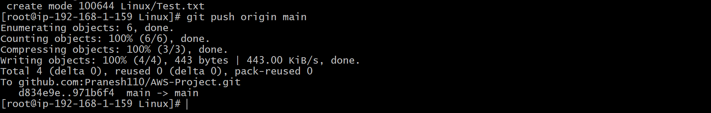



To pull the changes made in GITHUB: ( I have deleted the file in GITHUB)

1. git pull -- it will pull if any change made to local machine

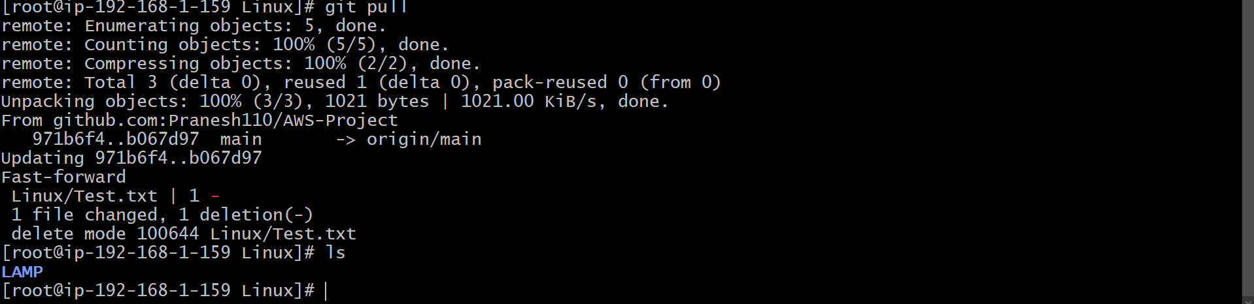

git status – to check what change made

git log – to check log

git config –list – to check what account is added

git stash --- temporary saving

git stash apply --saving the change